Contact: Christie Kozak | Leary PR | christie@learypr.com | 978-502-5747

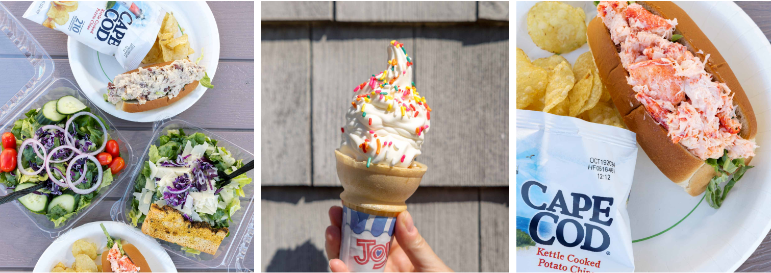

The Lobster Shack at Michael’s Harborside is Back for the Season

Now Serving Breakfast, Lunch and Dinner by the Water in Newburyport
NEWBURYPORT, MASSACHUSETTS (April 2025) – The Lobster Shack at Michael’s Harborside has officially reopened for the season, serving up fresh New England flavors from its popular takeout window. Nestled waterside along the Merrimac River, this local favorite is now offering an expanded offering of breakfast items for the first time, along with its signature lunch and dinner menu.
April School Vacation Hours:

- Monday, April 21 through Friday, April 25 from 11:30 a.m. to 7:00 p.m.
- Saturday, April 26 and Sunday, April 27 from 8:00 a.m. to 7:00 p.m.

Early Spring Hours Week of Monday, April 28:

- Monday through Thursday: 4:00 p.m. to 8:00 p.m.
- Friday through Sunday: 8:00 a.m. to 7:00 p.m.

Extended hours begin in May, visit MichaelsHarborside.com for full listing.
Guests can start their day by enjoying a scenic breakfast featuring coffee and tea, avocado toast, breakfast sandwiches, bagels, and more. Fan favorites return including Lobster rolls, clam chowder, lobster bisque, fried clams, salads, ice cream and more. Plus, The Lobster Shack is dog-friendly – furry friends are welcome and can enjoy their very own pup cups.
The Lobster Shack’s casual outdoor seating makes it the perfect spot for a laid-back lunch, sunset dinner, or a mid-day treat. Guests can play outdoor lawn games including cornhole and giant Jenga. Whether you’re fueling up for a day on the water or grabbing a quick bite post-walk, there’s something for everyone.
The Lobster Shack takeout window is in the parking lot to the right of the main entrance at Michael’s Harborside. With direct access to the Newburyport Rail Trail and Newburyport Marinas, it’s a convenient stop for visitors and locals alike.

“Michael’s Lobster Shack is excited to celebrate our third season with new menu items, expanded hours, and lots of fun and games for our guests to enjoy,” says Mathew Kirk, General Manager of Michael’s Harborside.

Michael’s Harborside
Michael’s Harborside is Newburyport’s premier waterfront seafood restaurant. Overlooking the Merrimack River, Michael’s Harborside is a favorite of locals who dine out often, boaters staying at one of the many marinas, and tourists who come to get a true taste of New England. Whatever the weather outside, Michael’s Harborside is always warm and welcoming with fireside dining in the winter and the most popular (and family-friendly!) outdoor decks and bar in Newburyport during the warmer months. For more information, visit
MichaelsHarborside.com.

Newburyport Development
Newburyport Development, a New England Development Company, is located in the heart of downtown Newburyport, Massachusetts, where you’ll find historic neighborhoods and cobblestone streets alongside contemporary restaurants, a shopper’s paradise, and modern galleries. As one of Newburyport’s leading property owners and property managers, Newburyport Development owns more than 50 prime retail/office locations and residential units throughout downtown Newburyport, plus Newburyport Marinas, and Michael’s Harborside restaurant. Newburyport shops include Native Sun, Lively Kids, Best of British, Talbots, M.K. Benatti Jewelers, SOAK & Shoreline and many more. Dining selections feature Michael’s Harborside, Tuscan Sea Grill & Bar, BRINE Oyster Bar, The Poynt, Port Vida Mexican Cantina, Oregano Pizzeria and Ristorante, The Angry Donut, and The Goat, among others. All are part of Newburyport’s vibrant waterside setting, which offers some of New England’s best fishing, boating, dining, and shopping. For more information, visit NewburyportDev.com and NewburyportShops.com.

